17 November 2020
DRAFT
Using the GeMS Validate Database tool
gems@usgs.gov

The GeMS Validate Database tool is part of the GeMS Tools ArcGIS toolbox of geoprocessing tools. There are two versions, one for use with ArcMap and one for use with ArcGIS Pro. Both are available on Github:
ArcMap: https://github.com/usgs/gems-tools-arcmap
ArcGIS Pro: https://github.com/usgs/gems-tools-pro
At either repository, download by clicking on the green Code button and choose Download ZIP
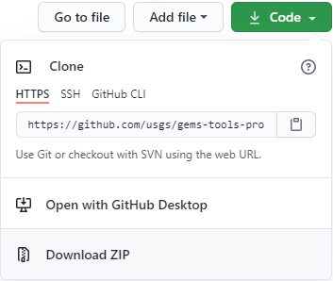
Unzip the GeMS toolbox
The downloaded zip file will be named gems-tools-master-arcmap.zip or gems-tools-master-arcpro.zip. Unzip the file someplace safe and where you can find it, perhaps in C:\Users\<yourname>.
Add the GeMS toolbox to Arc
In ArcMap:
Open ArcMap or ArcCatalog and tap from the Standard toolbar to open the ArcToolbox window. Right-click on white area within the window and select Add Toolbox…
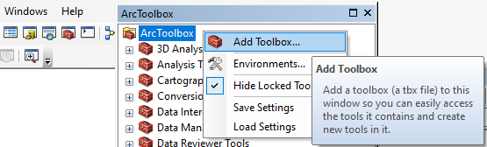
Navigate to the where you unzipped the toolbox file and select GeMS_ToolsArc105.tbx, or GeMS_ToolsArc10.tbx if you are using ArcGIS version 10.0 – 10.4.
Right-click on white area within the ArcToolbox window again and select Save Settings > To Default. If in ArcMap, save your map composition. MAYBE the next time you open ArcMap the toolbox will be loaded.
You can also navigate to the toolbox in the Catalog window at any time if you have stored a Folder Connection to the toolbox folder or any folder higher in the directory tree. Right-click on Folder Connection, choose Connect To Folder, and navigate to the folder.
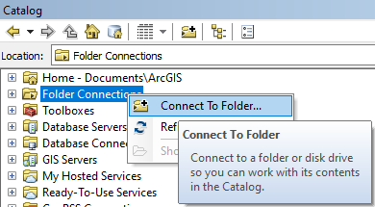
In ArcGIS Pro:
Open Pro. Open the Catalog Pane and, with the Project tab selected, right-click on Toolboxes. Choose Add Toolbox and navigate to the folder where you unzipped the file from Github and select GeMS_Tools_AGP2.tbx. This adds a connection to the toolbox that is saved within the current Project.
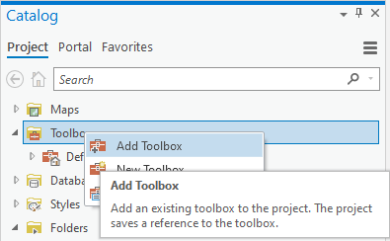
To avoid repeating these steps for every project, add a Folder connection that is saved in the Catalog Pane for all projects: In the Catalog Pane, select the Favorites tab. Click Add Item > Add Folder. Navigate to the folder containing the toolbox (or any folder higher in the directory tree) and click OK.
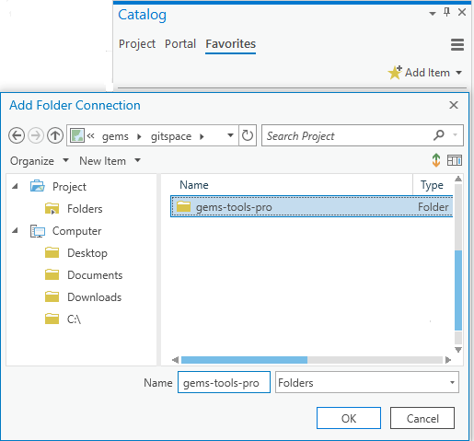
When the folder appears, right-click on it and choose Add to New Projects.
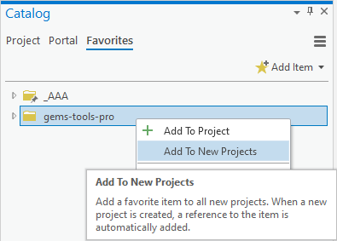
This folder will now be listed under the Folders item on the Project tab for all new projects. To add the folder connection to the current project, go back to the Favorites tab, right-click on the folder and choose Add To Project.
Use the Validate Database tool
Expand the GeMS_Tools toolbox. Scroll down and double-click Validate Database to open the tool. The within-tool documentation should be sufficient to get you started, and more.
Look at the output
Double click on <MyDatabase>.gdb-Validation.html and it should open in a browser window. The contents of this file are intended to be self-explanatory. If they are not, please let us know.
Cautions
If you are using ArcMap, scroll down to the bottom of the initial page of the within-tool documentation to see warnings about some peculiarities of ArcGIS that we have not been able to code around.
If you are using ArcGIS Pro and you get results that seem nonsensical, try running the tool from an empty map.
There are extensive instructions for using GeMS and the GeMS tools at https://github.com/usgs/gems-tools-arcmap/wiki.
As we write this, the GeMS standard (available in draft form at https://ngmdb.usgs.gov/Info/standards/GeMS) is close to publication. Finalization of the standard has occasioned some changes in the Validate Database tool.
- Most significant are minor changes to definitions of terms in GeoMaterialDict. These changes do not change the sense of the definitions. However, databases built with earlier versions of the GeMS toolbox generate numerous errors associated with GeoMaterialDict and GeoMaterial values. To easily fix these errors, check the Refresh GeoMaterialDict box on the Validate Database tool interface.
- Validate Database also now checks for valid topology in GeologicMap and any cross-section feature datasets. To perform this check the tool copies the MapUnitPolys feature class to a scratch database. If the database contains feature-linked annotation for MapUnitPolys this crashes ArcMap and ArcCatalog. To prevent this, delete the associated relationship class. Behavior in ArcGIS Pro is unknown.
- Validate Database is intentionally picky about string values in table fields. Bad nulls (empty strings, white-space strings, and “<null>” (as a text string) are errors. Leading or trailing spaces generate warnings. String values may be pre-emptively repaired with the Fix Strings tool in the GeMS toolbox (currently in the ArcMap version only).
The new version of Validate Database has not been used extensively and may have bugs. If you encounter a bug please let us know by emailing gems@usgs.gov.

